A PROJECT REPORT

On

#### CLEVER TOUCH APPLICATION

Submitted By

#### NIRALI PANDYA (206950307011)

For partial fulfilment of the award Of

#### DIPLOMA ENGINEERING

In Computer Engineering

Guided by

#### Prof. D.C. Dhadhal



**Dr. Subhash Technical Campus – Junagadh. Gujarat Technological University, Ahmedabad**

#### 2023

#### Dr. Subhash Technical Campus – Junagadh Diploma in Computer Engineering

**2023**



CERTIFICATE

This is to certify that the project entitled **“CLEVER TOUCH”** Application has been carried out by **NIRALI PANDYA (206950307011)** under guidance of **Prof. D.C. Dhadhal** in partial fulfillment of the Diploma in Computer Engineering, Gujarat Technological University, Ahmedabad during the academic year 2022- 23.

##### Date:

**Sign of Guide**

**Sign of HOD**

## ACKNOWLEDGEMENT

I would like to articulate our profound gratitude and indebtedness to those persons who helped me in completion of the project. First and foremost, I would like to convey our gratefulness to our project Guide **Prof. D.C. Dhadhal** for his constant and motivation and valuable suggestions throughout the project duration. I truly appreciate all faculty members for providing a solid background for my studies and research thereafter, which helped a lot to properly shape the problem and provided insights towards the solution.

I also want to express my sincere gratitude to **Dr. H.H. Patel**, Head of the department Computer Engineering for giving valuable guidelines in the project.

I am also very thankful to my batch mates, who always encouraged and helped me in the successful completion of my project work.

##### Nirali Pandya

## ABSTRACT

All people are running behind development in this generation. Development is good for us but it has bad effect in children. There are 73% children using mobile for other fun & passing the time and therefore their development is hampered due to mobile. In this busy schedule, Parents cannot give time to their children Hence we are developing the learning app for creating bond with parents and children. The aim of this application is help in the early child development. CLEVER TOUCH is basically for 2 to 9 years children. This learning app provides activity like guess the animal and their sound, Identify and choose the color, Numbering, Demonstrative objectives, Collecting things, Volley balloons, Alphabets with words, How to respect elders, recognize things, How to learn and remember and many more by videos and tasks. Parents have to spent very less time from their busy schedules for this application. To give a path to such a good idea we are using Android technology.

**INDEX**

###### Acknowledgment Abstract

**Index**

###### List of Figures List of Tables

I

II IV IX

|  |  |  |
| --- | --- | --- |
| **Chapter: 1** | **Project Introduction** | **04** |
|  | 1.1 Project Profile | 05 |
|  | 1.2 Definition | 05 |
|  | 1.3 Objectives | 05 |
|  | 1.4 Scope | 06 |
| **Chapter:2** | **System Profile** | **07** |

* 1. System Analysis
     1. Software Development Life Cycle 08
     2. System about project requirement 10
  2. Feasibility Study
     1. Technical Feasibility 13
     2. Economical Feasibility 13
     3. Operational Feasibility 14

|  |  |  |
| --- | --- | --- |
|  | 2.3 System Requirement | 15 |
| 2.4 User Requirement | 15 |
| **Chapter:3** | **Project Management** | **16** |
|  | 3.1 Project Planning | 17 |
|  | 3.2 Project Schedule | 18 |
|  | 3.3 Cost Estimation | 19 |
| **Chapter:4** | **Design Analysis** | **20** |
|  | 4.1 E-R Diagram | 21 |
|  | 4.2 Usecase Diagram | 26 |
|  | 4.3 Data Flow Diagram | 22 |
|  | 4.4 Activity Diagram | 27 |
| **Chapter:5** | **Implementation** | **28** |
|  | 5.1 Data Dictionary | 29 |
|  | 5.2 Screenshots of Home page design and Login | 31 |

###### Future Scope References

|  |  |  |
| --- | --- | --- |
| **Figure No.** | **Title** | **Page No.** |
| Figure 2.1.1.1 | SDLC Life cycle | 05 |
| Figure 2.1.1.2 | Iterative Model | 07 |
| Figure 3.2.1.2 | Gantt chart | 15 |
| Figure 4.1.1.3 | E-R Diagram | 18 |
| Figure 4.2.1.4 | Dataflow Diagram | 19 |
| Figure 4.2.1.9 | Use case Diagram | 23 |
| Figure 4.2.1.9 | Activity Diagram | 24 |

|  |  |  |
| --- | --- | --- |
| **Table No.** | **Title** | **Page No.** |
| 5.1.1 | User | 26 |
| 5.1.2 | Video | 26 |
| 5.1.3 | Task | 26 |
| 5.1.4 | Stories | 27 |
| 5.1.5 | Display | 27 |

**CLEVER TOUCH Group_ID : CEDIP5_8**

# Chapter 1 Introduction to Project

### Project Profile

* 1. **Definition**

### Objective

* 1. **Scope**

DIPCE 1

* 1. **Project Profile**

|  |  |
| --- | --- |
| **Project title:** | CLEVER TOUCH |
| **Operating system:** | Windows 11 |
| **Front End Side:** |  |
| **Admin Side:** Android studio, Java |
| **User Side:** Application |
| **Nature of Project:** | Software application |
| **Duration:** | 4 months |
| **Project Guide:** | Prof. D.C. Dhadhal |
| **Submitted to:** | Dr. Subhash Technical Campus |
| **Submitted By:** | Nirali Pandya |

* 1. **Definition**

CLEVER TOUCH is an application that will be capable of helping in good development for children and it provides learning videos or tasks that will helping children to develop a good frame of mind.

* 1. **Objective**
     + This application provide platform for wondering different thoughts that will be help on children development.
     + Most of the time the children need time from their parents but from in that time you have to give less time to this application so that children feel free and frankly with parents.
     + This application also provide videos that help in physical activities; tasks that help in learning and testing and story books for fun and knowledge.
     + From these all activities children get courage to do new things.
     + From this application children and parents will get communicate, so this will be helpful for both.
  2. **Scope**
* To create bond with parents and child.
* Provide tasks, videos and story books for mind growth.
* To learning new things for children.
* For helping in communication between parents and child.
* To give time for children from parent’s busy schedule.

# Chapter 2 System Profile

### System Analysis

### Feasibility Study

### System Requirement

* 1. **User Requirement**
  2. **System Analysis**
     1. **System Development Life Cycle:**

What is SDLC? SDLC is a process followed for a software project, within a software organization. It consists of a detailed plan describing how to develop, maintain, replace and alter or enhance specific software. The life cycle defines a methodology for improving the quality of software and the overall development process.

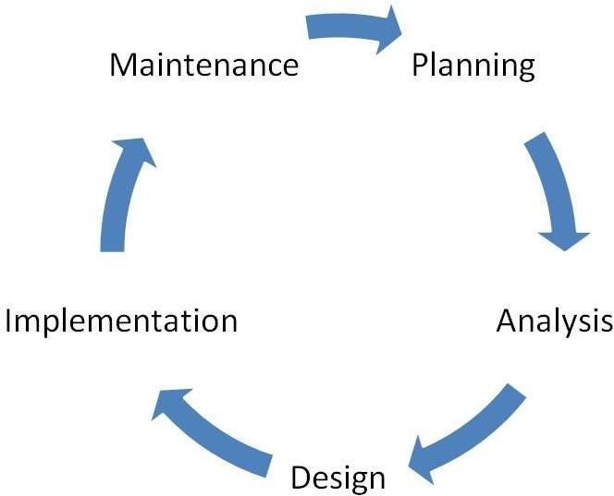

Maintenance

Testing

###### Figure 2.1.1.1 : [SDLC Life Cycle]

There are following Five phase in every Software development life cycle model:

* + - 1. Requirement gathering / analysis
      2. Design
      3. Implementation or coding
      4. Testing
      5. Maintenance

1. **Analysis:**

Business requirements are gathered in this phase. This phase is the main focus of the project managers, stake holders and users are held in order to determine the requirements like; who is going to use the system? How will they use the system? What data should be input into the system? What data should be output by the system? These are general questions that get answered during a requirements gathering phase. After requirement gathering these requirements are analyzed for their validity and the possibility of incorporating the requirements in the system to be development is also studied. Finally, a requirement specification document is created which serves the purpose of guideline for the next phase of the model.

###### Design:

In this phase the system and software design is prepared from the requirement specifications which were studied in the first phase. System design helps in specifying hardware and system requirements and also helps in defining overall system architecture. The system design specification serve as input for the next phase of the model.

##### Implementation /Coding:

On receiving system design documents, the work is divided in modules/units and actual coding is started. Since, in this phase the code is produced so it is the main focus for the developer. This is the longest phase of the software development life cycle.

###### Testing:

After the code is developed it is tested against the requirements to make sure that the product is actually solving the needs addressed and gathered and gathered during the requirements phase. During this phase unit testing, integration testing, system testing, acceptance testing are done.

##### Maintenance:

Once when the customers start using the developed system then actual problems comes up and needs to be solved from time to time. This process where the care is taken for the developed product is known as maintenance.

**Spiral Model:**

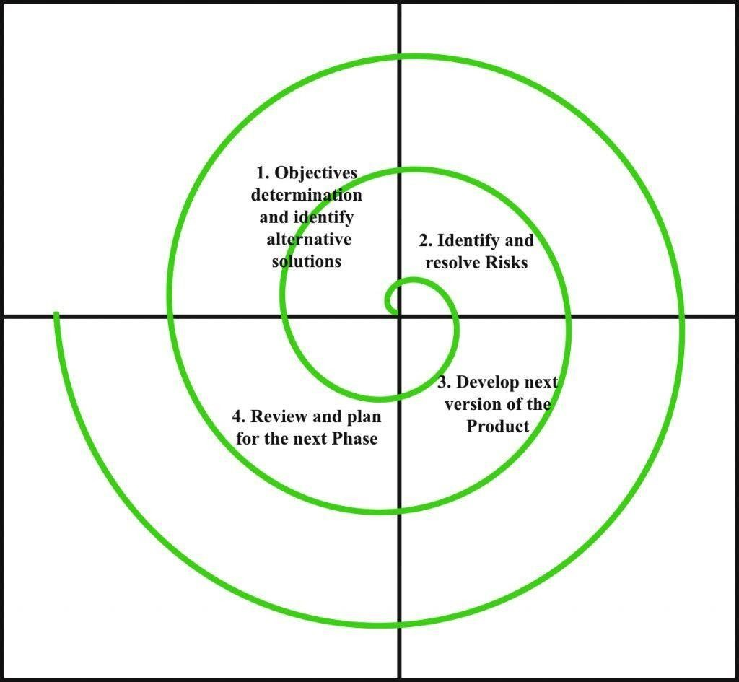

###### Figure 2.1.1.2 :[Spiral model]

Each phase of the Spiral Model is divided into four quadrants as shown in the above figure. The functions of these four quadrants are discussed below-

###### Objectives determination and identify alternative solutions:

Requirements are gathered from the customers and the objectives are identified, elaborated, and analysed at the start of every phase. Then alternative solutions possible for the phase are proposed in this quadrant.

###### Identify and resolve Risks:

During the second quadrant, all the possible solutions are evaluated to select the best possible solution.

Then the risks associated with that solution are identified and the risks are resolved using the best possible strategy. At the end of this quadrant, the Prototype is built for the best possible solution.

###### Develop next version of the Product:

During the third quadrant, the identified features are developed and verified through testing. At the end of the third quadrant, the next version of the software is available.

###### Review and plan for the next Phase:

In the fourth quadrant, the Customers evaluate the so far developed version of the software. In the end, planning for the next phase is started.

* **Benefits of the spiral model**

The spiral model is a great option for large, complex projects. The progressive nature of the model allows developers to break a big project into smaller pieces and tackle one feature at a time, ensuring nothing is missed. Furthermore, since the prototype building is done progressively, the cost estimation of the whole project can sometimes be easier.

* + **Flexibility** - Changes made to the requirements after development has started can be easily adopted and incorporated.
  + **Risk handling** - The spiral model involves risk analysis and handling in every phase, improving security and the chances of avoiding attacks and breakages. The iterative development process also facilitates risk management.
  + **Customer satisfaction** - The spiral model facilitates customer feedback. If the software is being designed for a customer, then the customer will be able to see and evaluate their product in every phase. This allows them to voice dissatisfactions or make changes.

##### Disadvantages of Spiral Model:

* + It is not suitable for small projects as it is expensive.
  + It is much more complex than other SDLC models. Process is complex.
  + Too much dependable on Risk Analysis and requires highly specific expertise.
  + Difficulty in time management. As the number of phases is unknown at the start of the project, so time estimation is very difficult.
  + Spiral may go on indefinitely.
  + End of the project may not be known early.
  + It is not suitable for low risk projects.
  + May be hard to define objective, verifiable milestones. Large numbers of intermediate stages require excessive documentation.

##### Why used Spiral model?

The spiral model enables gradual releases and refinement of a product through each phase of the spiral as well as the ability to build prototypes at each phase. The most important feature of the model is **its ability to manage unknown risks after the project has commenced**; creating a prototype makes this feasible.

##### Feasibility Study

* + - Feasibility Study in software engineering is a study to evaluate feasibility of proposed project or system. Feasibility study is one of stage among important four stages of Software Project Management Process.
    - As name suggests feasibility study is the feasibility analysis or it is a measure of the software product in terms of how much beneficial product development will be for the organization in a practical point of view.
* Feasibility study is carried out based on many purposes to analyze whether software product will be right in terms of development, implantation, contribution of project to the organization etc.

##### Technical Feasibility

* + - * In Technical Feasibility current resources both hardware software along with required technology are analyzed/assessed to develop project.
      * This technical feasibility study gives report whether there exists correct required resources and technologies which will be used for project development.
      * Along with this, feasibility study also analyzes technical skills and capabilities of technical team, existing technology can be used or not, maintenance and up-gradation is easy or not for chosen technology etc.

##### Economical Feasibility

* + - * In Economic Feasibility study cost and benefit of the project is analyzed.

Means under this feasibility study a detail analysis is carried out what will be cost of the

* + - * After that it is analyzed whether project will be beneficial in terms of finance for organization or not.

##### Operational Feasibility

* + - * In Operational Feasibility degree of providing service to requirements is analyzed along with how much easy product will be to operate and maintenance after deployment.
      * Along with this other operational scopes are determining usability of product, Determining suggested solution by software development team is acceptable or not etc.
  1. **System Requirement**
* Developer Requirement :

##### Hardware:

* + - PC or Laptop
    - Intel i5-1235U 1.30 GHz
    - Minimum 8 GB RAM recommended
    - Minimum 512 SSD-DDR 4

##### Software:

* + Android studio2.1.16-windows
  + Database - Firebase
  + JDK(Java Development Kit)
  1. **User Requirement**
* Android Device
* 512 MB RAM
* Good Internet Connection
* Application View

# Chapter 3 Project Management

### Project Planning

* 1. **Project schedule**

### Cost Estimation

* 1. **Project Planning:**
     + Project planning is part of project management, which relates to use of schedules such as Gantt chart to plan and subsequently report progress within the project environment.
     + Software project planning Is task, which is performed before the product of software actually starts.
     + It is there for the software production but involves no concerete activity that has any direction connection with software production; rather it is set of multiple process, which facilities software production.

###### Project planning :

Establishes a high-level view of intended project and determines its goals.

###### System analysis :

Refines project goals into defined functions and operations of the intened application. Analysis end-user information needs.

###### System Design :

Describes desired features and operations in detail, including screen layouts, business rules, process diagrams, pseudo code and other documentation

###### Implementation:

The real code is written here.

###### Testing:

Brings all the pieces together into a special testing environment, then checks for error, bugs and interoperability.

###### Maintenance:

What happens during the rest of the software’s life: changes, correction, addition and moves to a different computing platform and more?

This, the least glamorous and perhaps most important step of all, goes on seemingly forever.

### Project Schedule & Gantt chart:

* + - Project scheduling is one of the key aspects of any project. Any project must be schedule before developing it.
    - It describes dependency between activities. The estimated time required to allocation of people to activities.
    - This describes the way in which the development team is organized the people involved and their roles in team.

|  |  |  |  |  |  |  |
| --- | --- | --- | --- | --- | --- | --- |
| **Gantt Chart - Project Schedule** | | | | | | |
|  | 25-Aug-22 | 18-Sep-22 | 9-Oct-22 | 22-Jan-23 | 29-April-23 | 20-May-23 |
| Project Definition and study of tool |  |  |  |  |  |  |
| Introduction of the Project |  |  |  |  |  |  |
| System Profile and Analysis |  |  |  |  |  |  |
| System Management |  |  |  |  |  |  |
| Design Analysis |  |  |  |  |  |  |
| Implementation |  |  |  |  |  |  |

**Figure 3.2.1.2 :[Gantt Chart]**

### 3.2 Cost Estimation

* A cost estimation is a approximation of the cost of a program, project, or operation. The cost estimation is product of the cost estimating process. The cost Estimate has a single total value and may have identical component values.
* The cost spent in the making of the project is categorized into two parts.
  + Direct cost :
    - This is in terms of money. In this project in term of cost is :
      * Hardware
      * Software
      * System study
  + Indirect cost :
    - This is in terms of labor or the manual work. In this term of cost is :
      * Time spent in system analysis and design
      * Managing time for coding
      * Gathering report and referring other sources like the internet.

# Chapter 4 Design Analysis

### E-R diagram

* 1. **Dataflow Diagram**

### Use Case Diagram

* 1. **Activity Diagram**

### E-R Diagram

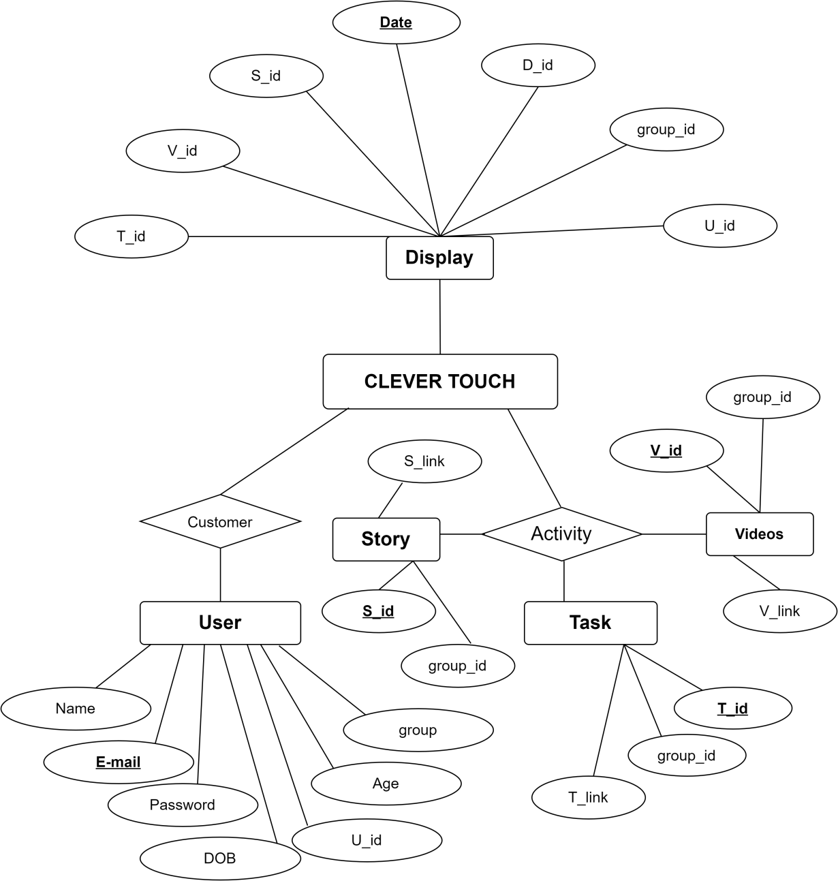

**Figure 4.1.1.3 :[E-R Diagram]**

### Dataflow Diagram

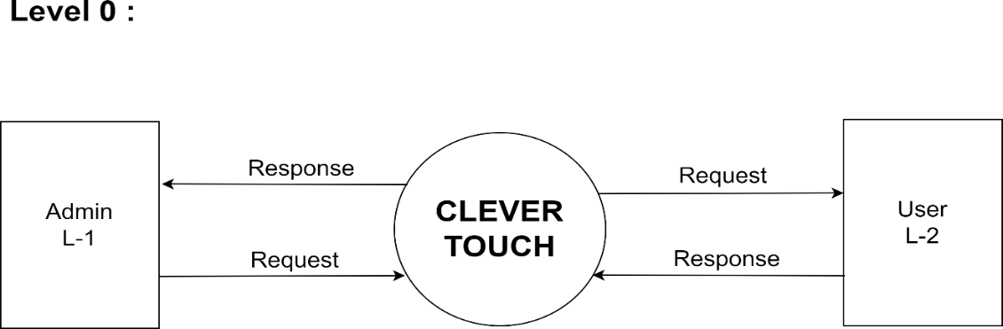

###### Figure 4.2.1.4 :[Dataflow Diagram][Level 0]

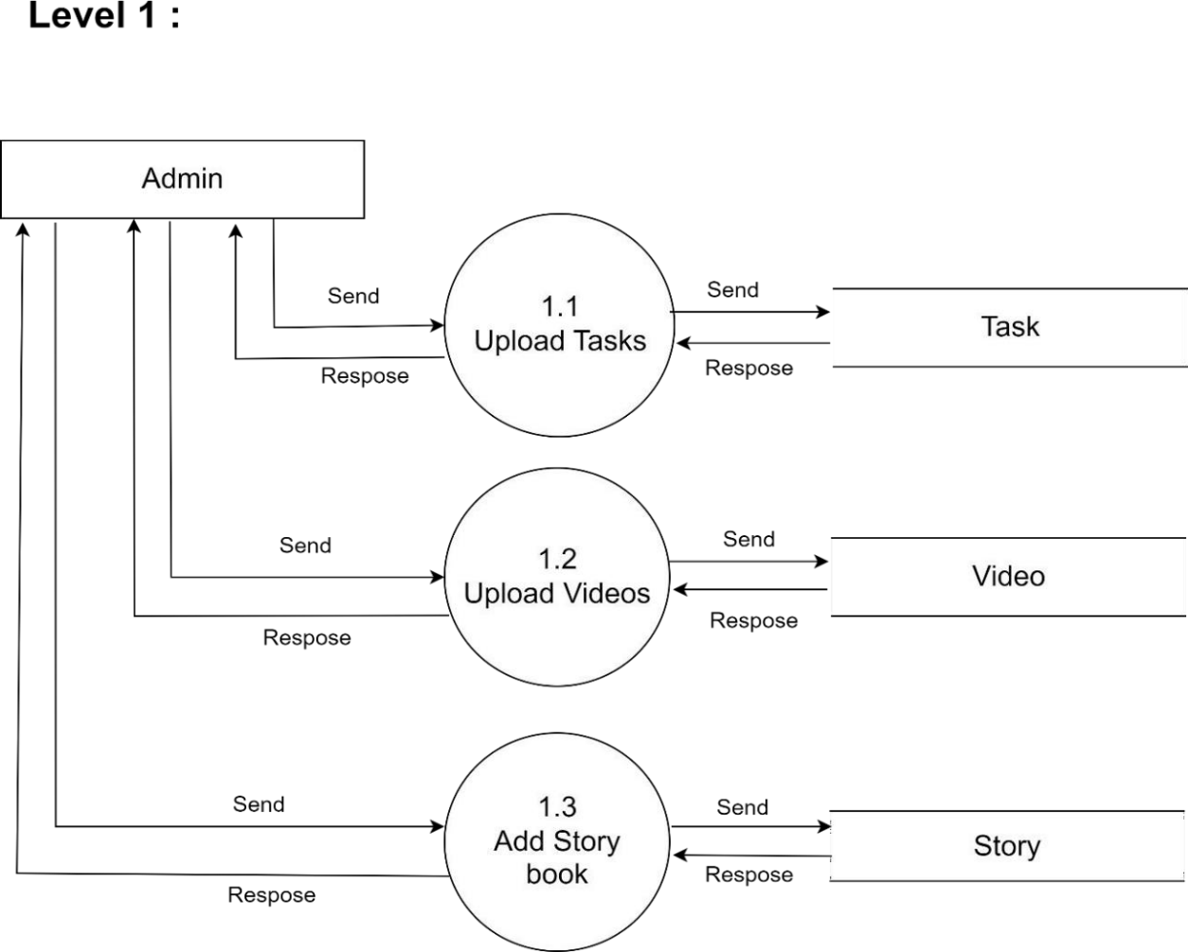

**Figure 4.2.1.5 :[Dataflow Diagram][Level 1]**

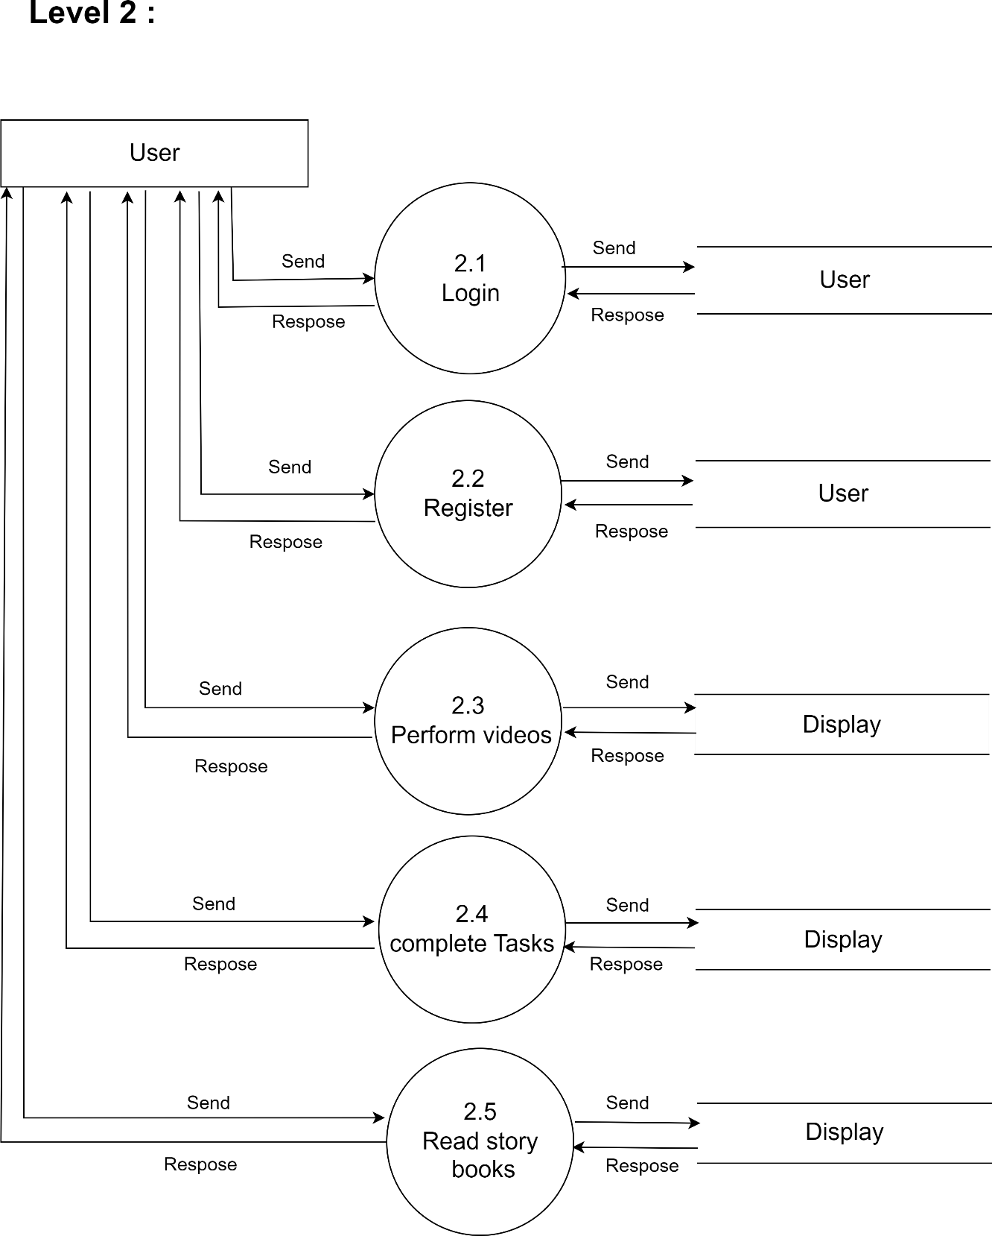

###### Figure 4.2.1.6 :[Dataflow Diagram][Level 2]

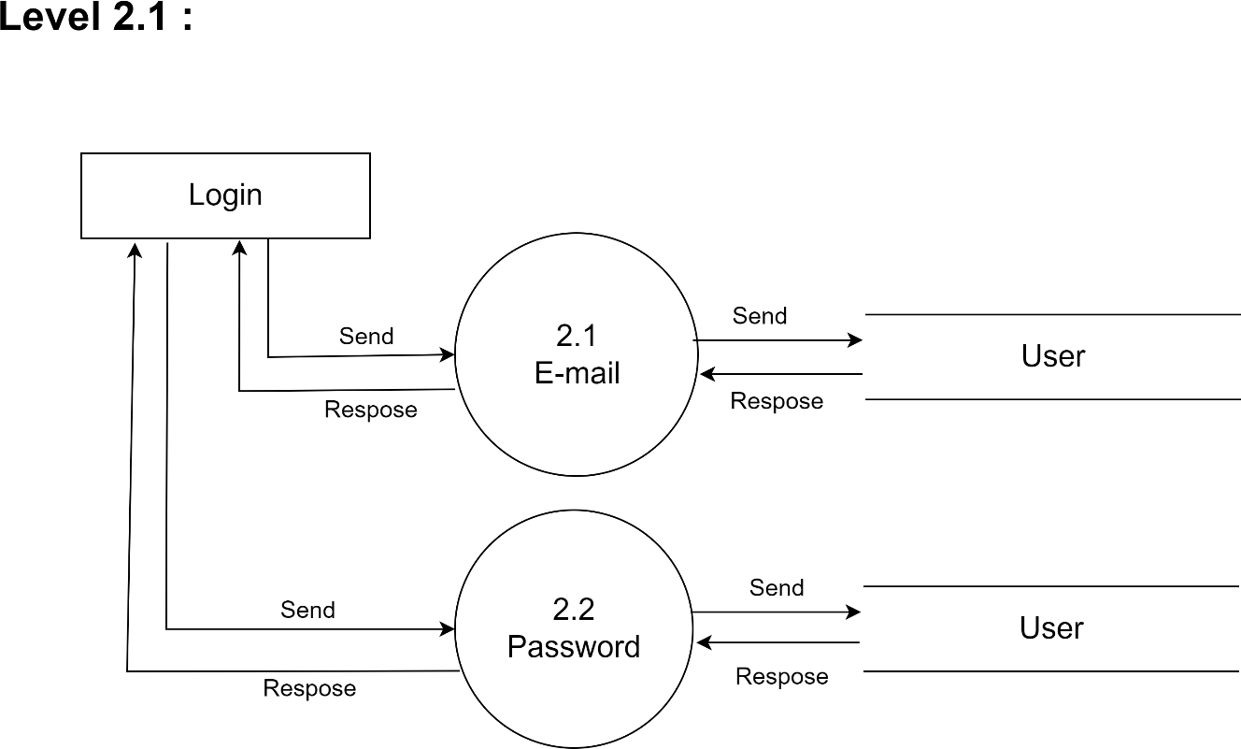

**Figure 4.2.1.7 :[Dataflow Diagram][Level 2.1]**

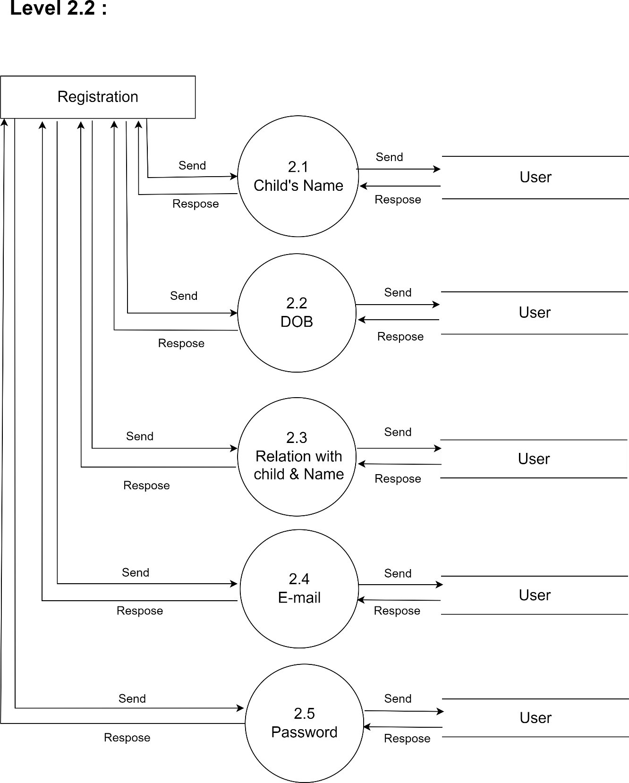

**Figure 4.2.1.8 :[Dataflow Diagram][Level 2.2]**

### Use Case Diagram

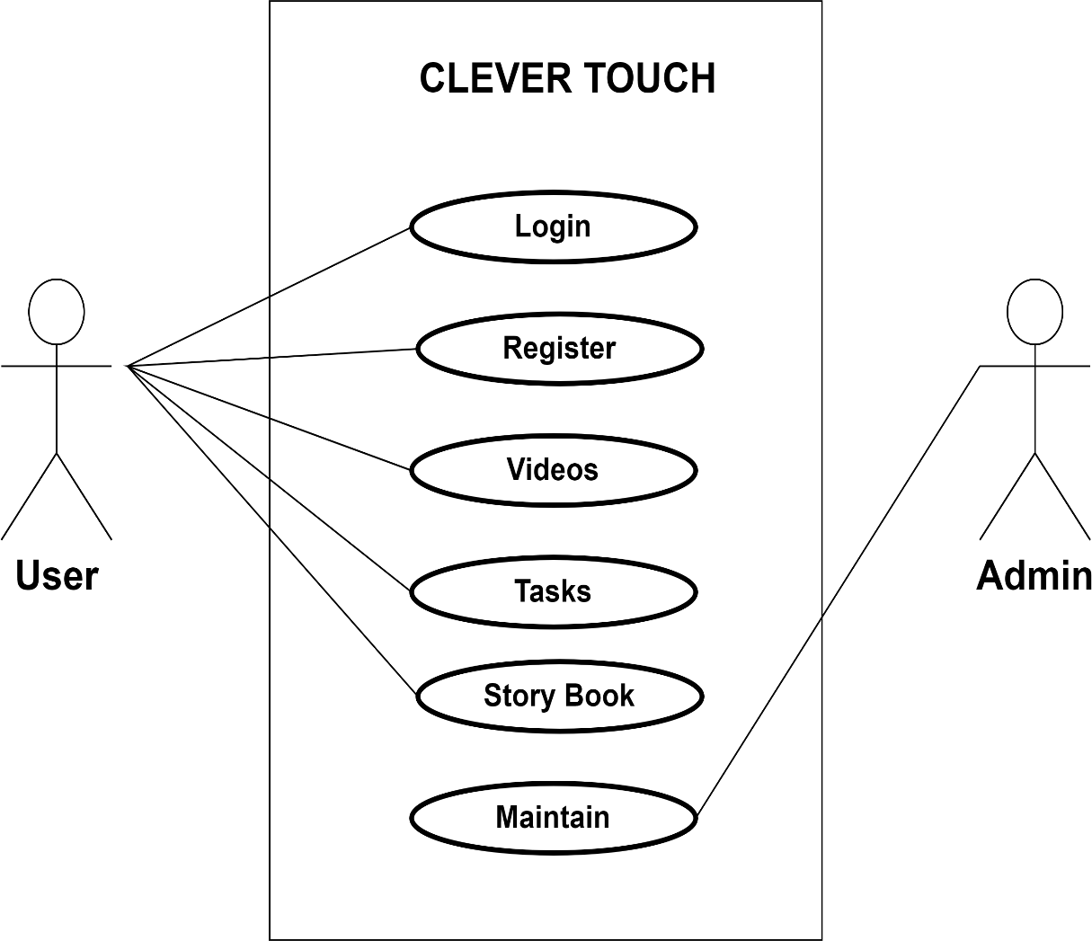

**Figure 4.2.1.9 :[Usecase Diagram]**

### Activity Diagram

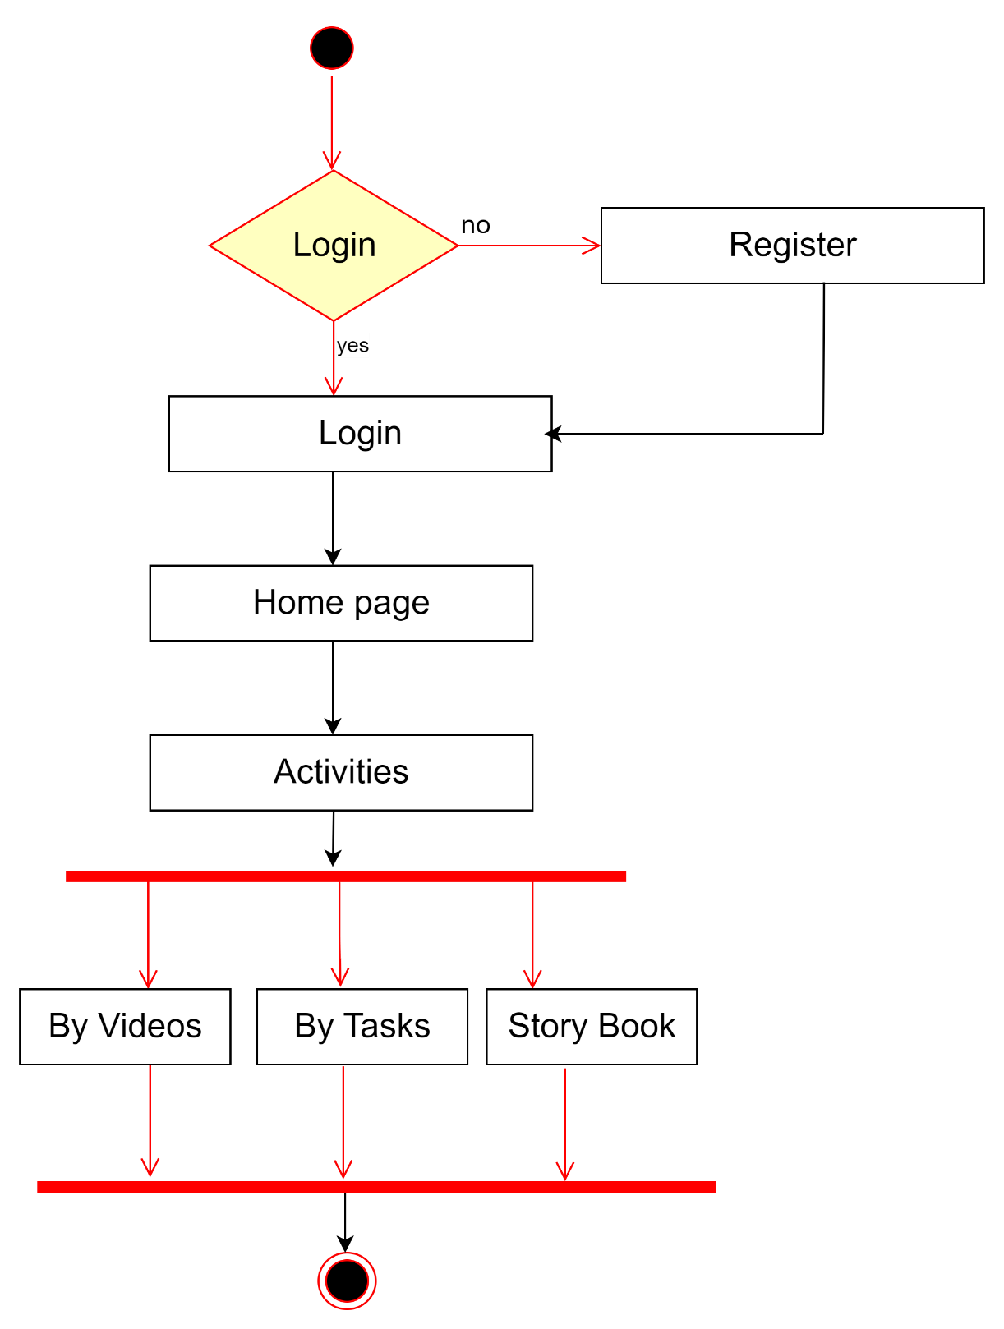

**Figure 4.2.1.10 :[Actvity Diagram]**

# Chapter 5 Implementation

### Data Dictionary

**5.2** **Screenshots of Application**

### 1.1 Data Dictionary

##### Table-5.1.1: [User]

|  |  |  |  |
| --- | --- | --- | --- |
| **Column Name** | **Data Type** | **Size** | **Constraint** |
| UID | CHARACTER | (15) | Not NULL |
| UName | VARCHAR | (30) | Not NULL |
| DOB | DATE | (10) | Not NULL |
| Email | VARCHAR | (25) | Primary Key |
| Password | VARCHAR | (25) | Not NULL |
| Age | NUMBER | (10) | Not NULL |
| Group | NUMBER | (2) | Not NULL |

* **Table-5.1.2: [Video]**

|  |  |  |  |
| --- | --- | --- | --- |
| **Column Name** | **Data Type** | **Size** | **Constraint** |
| VID | CHARACTER | (15) | Primary Key |
| Group | NUMBER | (30) | Not NULL |
| V_link | TEXT | (25) | Not NULL |

##### Table-5.1.3: [Task]

|  |  |  |  |
| --- | --- | --- | --- |
| **Column Name** | **Data Type** | **Size** | **Constraint** |
| TID | CHARACTER | (15) | Primary Key |
| Group | NUMBER | (30) | Not NULL |
| T_link | TEXT | (25) | Not NULL |

* + **Table-5.1.4: [Stories]**

|  |  |  |  |
| --- | --- | --- | --- |
| **Column Name** | **Data Type** | **Size** | **Constraint** |
| SID | CHARACTER | (15) | Primary Key |
| Group | NUMBER | (30) | Not NULL |
| S_link | TEXT | (25) | Not NULL |

* + **Table-5.1.5: [Display]**

|  |  |  |  |
| --- | --- | --- | --- |
| **Column Name** | **Data Type** | **Size** | **Constraint** |
| TID | CHARACTER | (15) | Foreign Key |
| VID | CHARACTER | (15) | Foreign Key |
| SID | CHARACTER | (15) | Foreign Key |
| UID | CHARACTER | (15) | Foreign Key |
| Group | NUMBER | (2) | Foreign Key |
| Date | DATE | (10) | Primary Key |
| DID | CHARACTER | (15) | Not NULL |

### 5.2 Screenshots

**Splash Screen:**

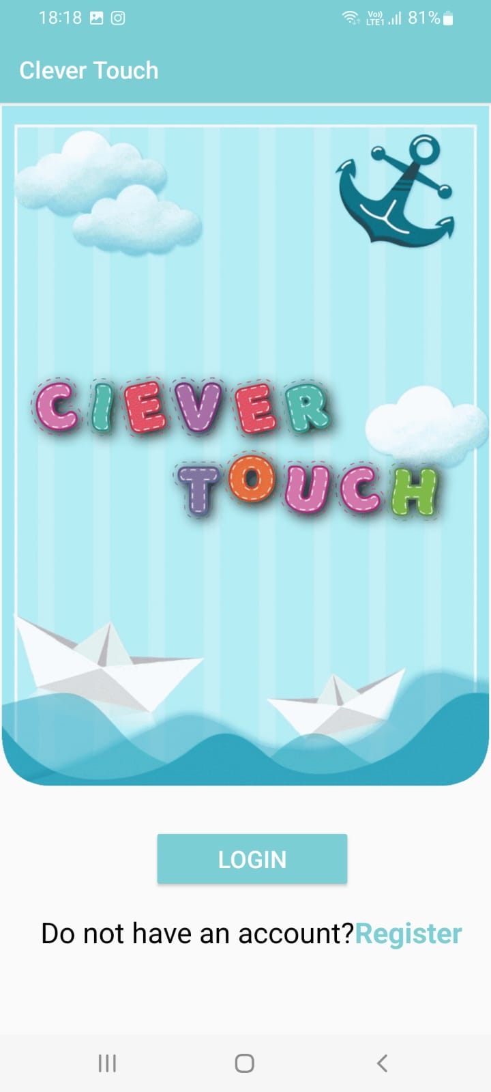

**Registration Page: Login Page:**

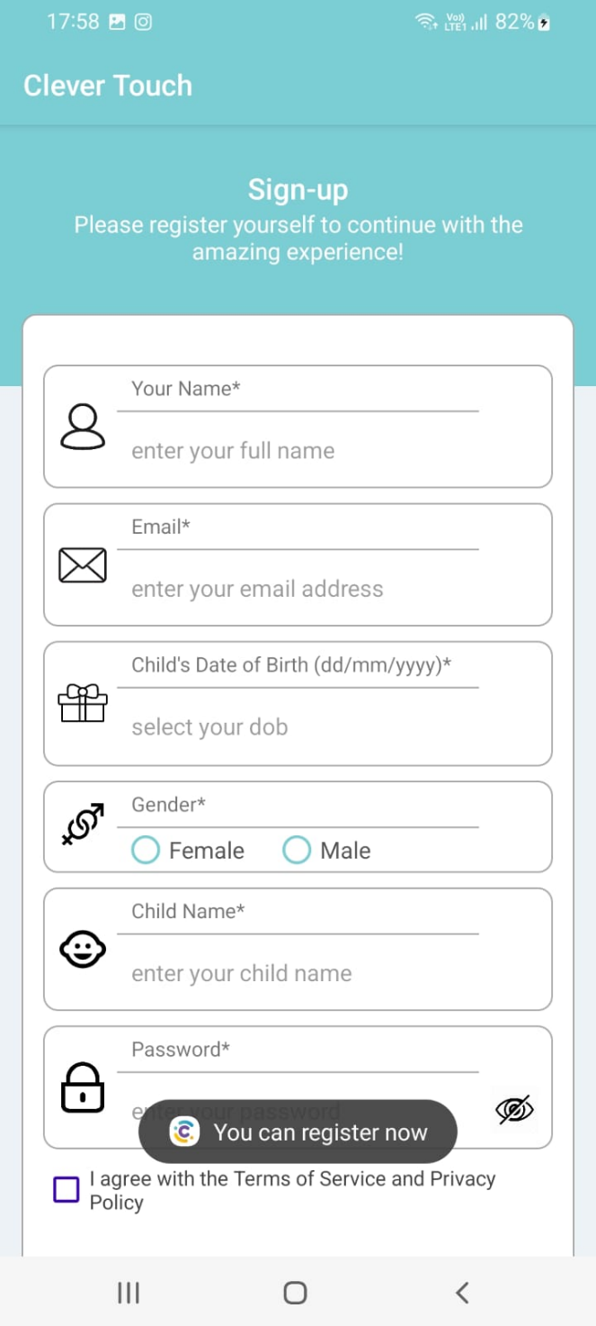

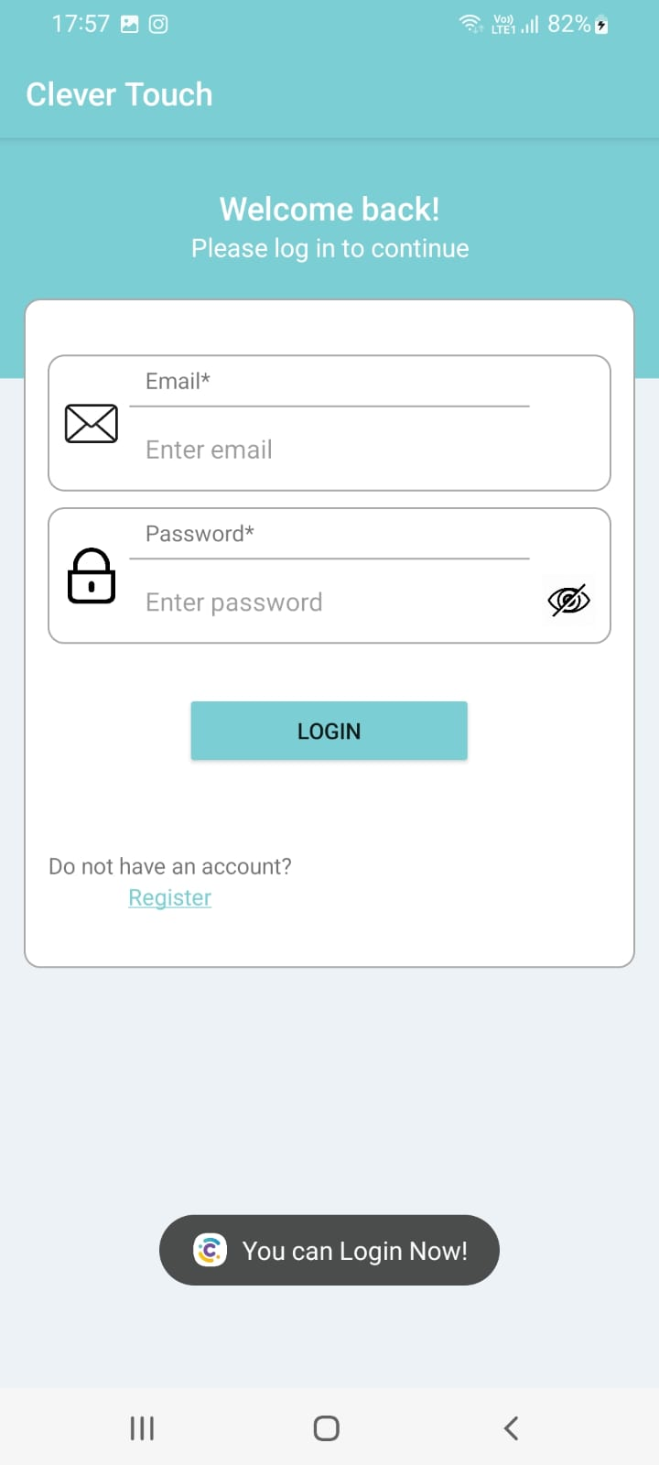

**Home Page: Question Page:**

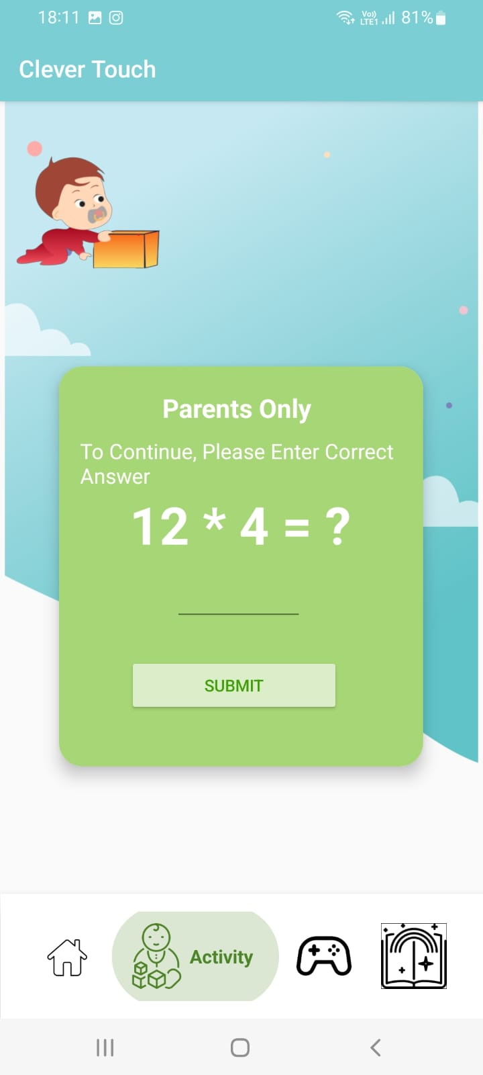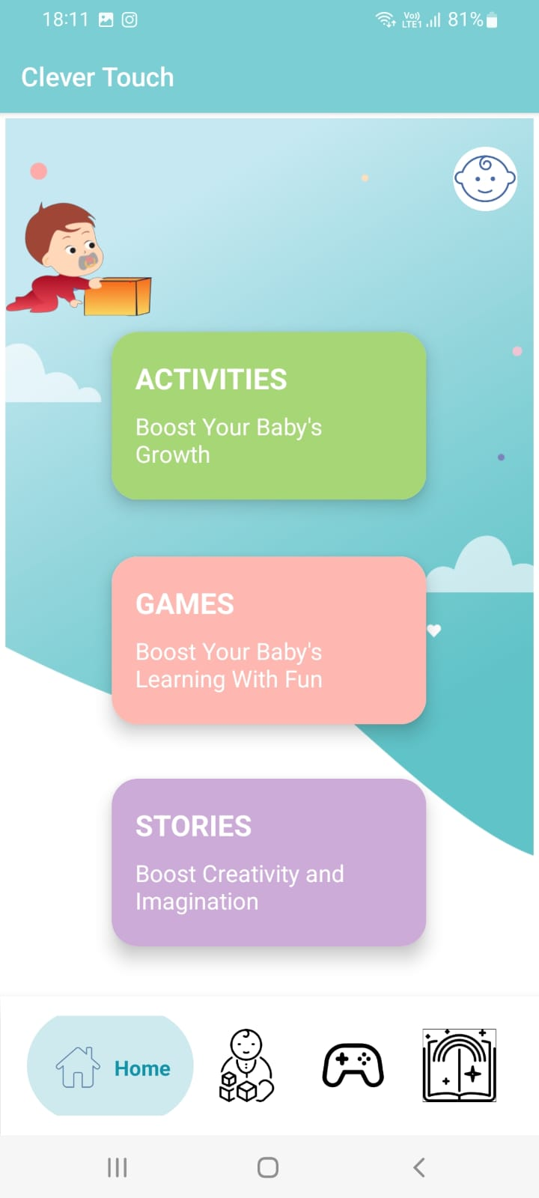

**Activity Page:**

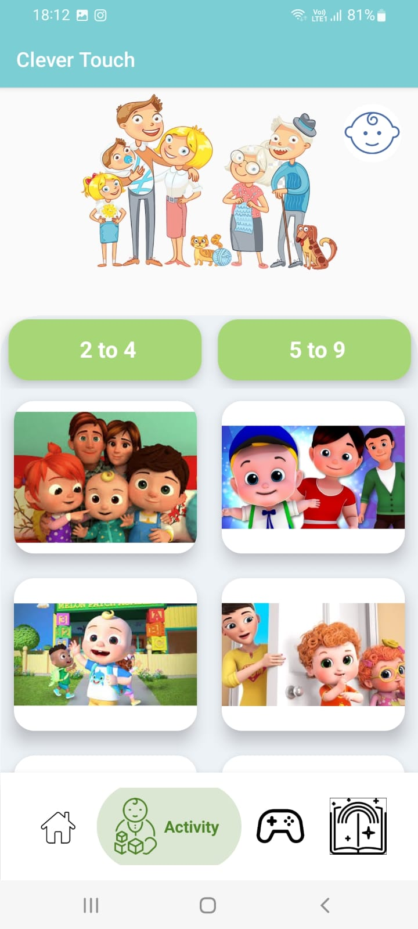

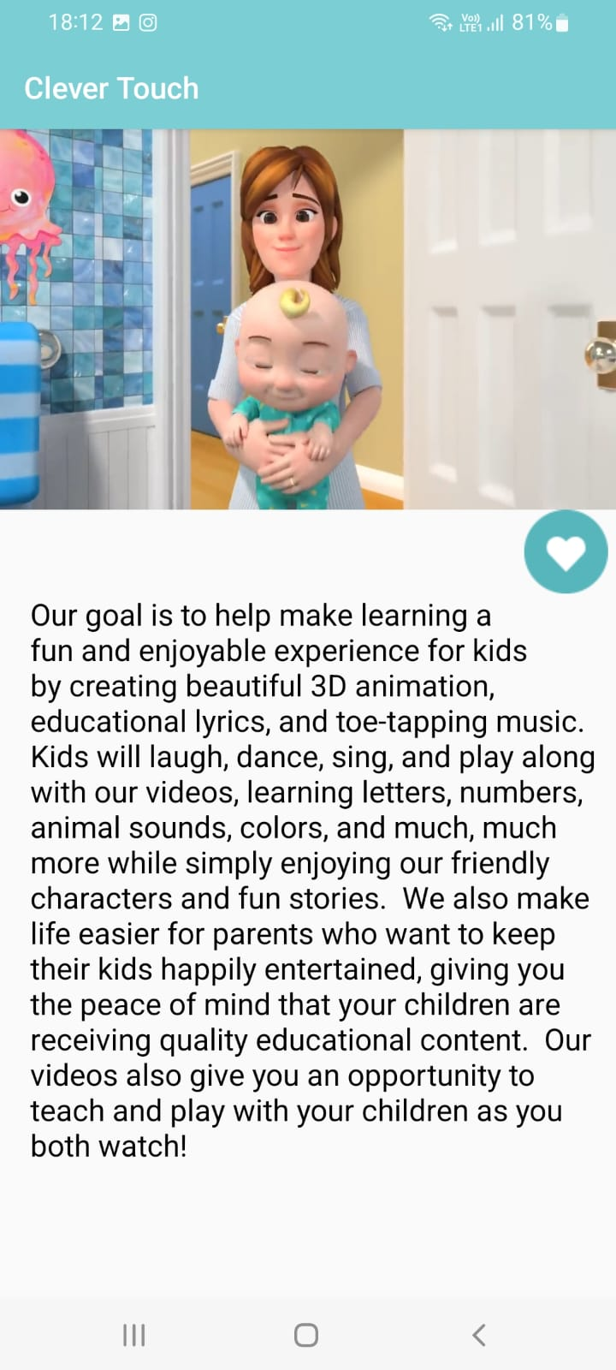

**Game Page:**

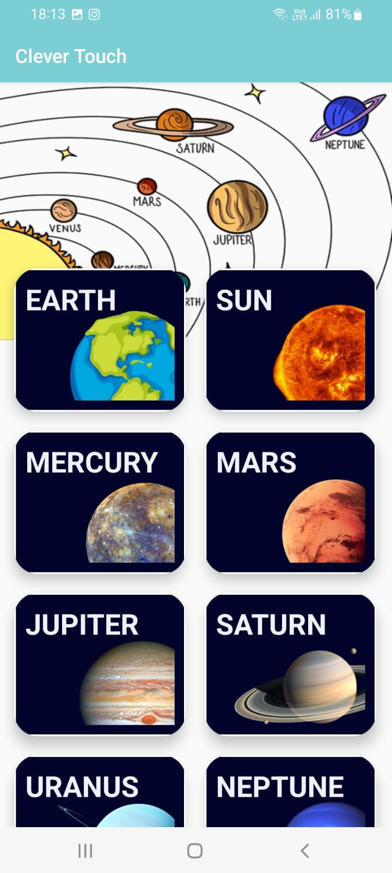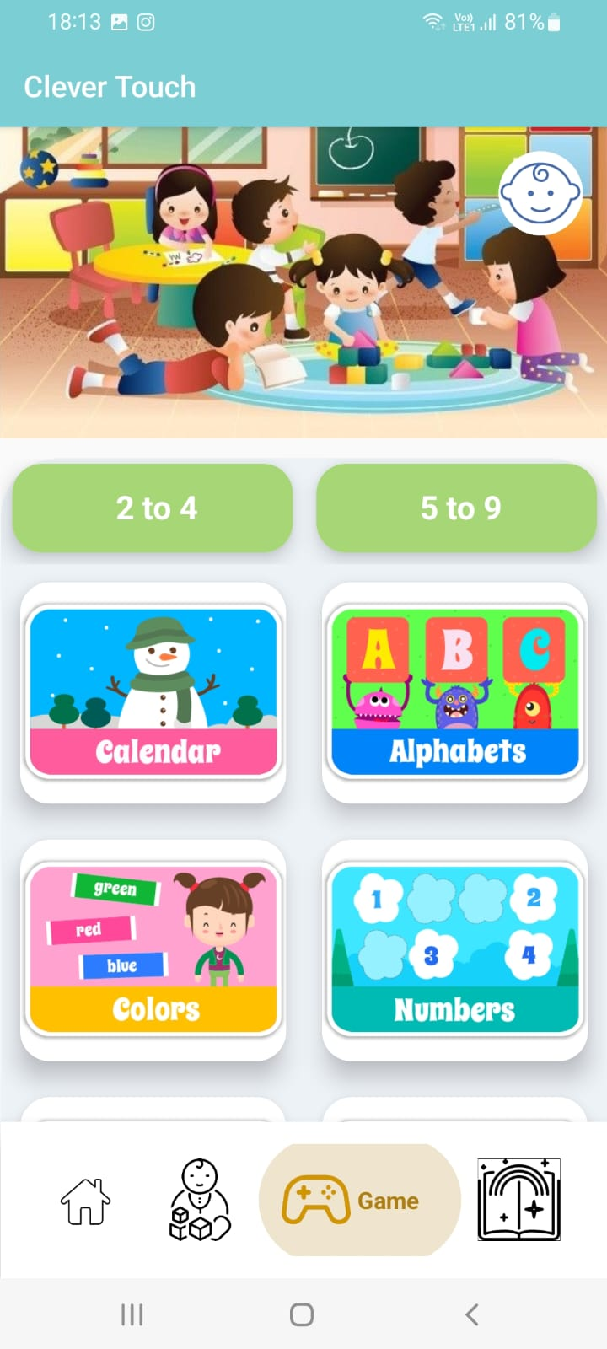

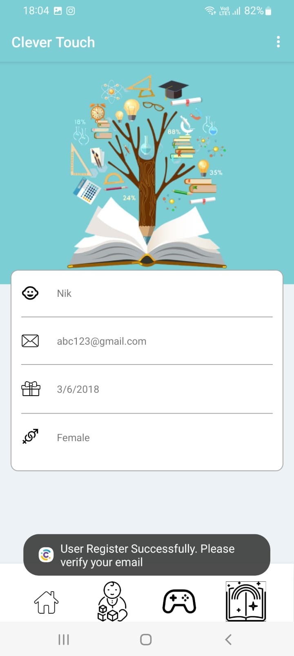**User Page:**

**REFRENCE**

1. https://[www.tutorialspoint.com/](http://www.tutorialspoint.com/)
2. https://[www. uml-diagrams.org//](http://www.uml-diagrams.org//)
3. https://[www. developer.android.com/](http://www.developer.android.com/)
4. <https://docs.oracle.com/javase/tutorial>//
5. https://en.wikipedia.org/wiki/Android_//

**FUTURE SCOPE**

* + This app will be helped to develop child’s development.
  + we give a different-different types task; with the helps of that taks child learn things. This application is use for being able to talk to parents well and for growth of mind.
  + Some other modules as per requirements can be added.